|  |
| --- |
| EPAM Systems, RD Dep. |
| Analysis of Milavitsa’s Sales |



Contents

[1. Business Description 3](#_Toc498028577)

[1.1. Business background 3](#_Toc498028578)

[1.2. Problems because of poor data management 3](#_Toc498028579)

[1.3. Benefits from implementing a Data Warehouse 3](#_Toc498028580)

[2. Data Description 5](#_Toc498028581)

[3. Dimensions of a Business 6](#_Toc498028582)

[3.1. Definition of selected Business Process 6](#_Toc498028583)

[3.2. Declaring the Grain 6](#_Toc498028584)

[3.3. Identifying the Dimensions 6](#_Toc498028585)

[3.4. Identifying the Facts 9](#_Toc498028586)

[3.5. Dimensional model. Star Schema 10](#_Toc498028587)

[3.5.1. Product part dimensions 11](#_Toc498028588)

[3.5.2. Store part dimensions 11](#_Toc498028589)

[3.5.3. Customer part dimensions 12](#_Toc498028590)

[3.5.4. Promotion dimensions 12](#_Toc498028591)

[3.5.5. Sales employee dimension 12](#_Toc498028592)

[3.5.6. Payment method dimension 12](#_Toc498028593)

[3.5.7. Date dimension 13](#_Toc498028594)

# Business Description

## Business background

For many years Milavitsa has been producing lady’s lingerie, being one of the biggest lingerie producer in Eastern Europe. The company's products are successfully sold in more than 25 countries around the world and are characterized by high quality, original and fashionable designs.

Company has four main brands:

1. **Milavitsa.**

The Milavitsa product portfolio includes bras, knickers, shapewear, knitwear and swimwear. The Milavitsa collection is divided into three categories: classic, fashion and swimwear. The basis of the classic collection is formed by a large variety of everyday styles, combining the basics of classical design, comfortable construction and functional materials. Milavitsa is an expert in creating the styles of large sizes. Fashion and swimwear collections are created for every season, following the fashion trends in design, materials and accessories.

1. **Avelive Collection.**

Bras, knickers, shapewear are also manufactured under the Aveline trademark. This is comfortable everyday lingerie at affordable prices. The Aveline products are developed and manufactured by Milavitsa, which is a guarantee of high quality and compliance with the company’s standards.

1. **Alisee.**

Alisee is a French lingerie brand acquired by Milavitsa. Alisee collection is designed and styled by European professionals. Tailored by Milavitsa to fit local market specifics.

1. **Hidalgo.**

The Hidalgo is men's underwear combines classic shapes and comfortable natural materials.

## Problems because of poor data management

Company faced next problems:

1. absence of business intelligence from several sources;
2. absence of sales and inventory information consolidation for the calculation of the optimal order and delivery;
3. decreasing query and system performance;
4. absence of timely access to data;
5. absence of historical intelligence.

## Benefits from implementing a Data Warehouse

1. **Better decision-making.** Corporate decision makers will no longer have to make important business decisions based on limited data and hunches. Data warehouse will store credible facts and statistics, and decision makers will be able to retrieve that information from the data warehouse based on their personal needs.
2. **Quick and easy access to data.** Speed is an important factor that sets company above its competitors. Business users can quickly access data from multiple sources from a data warehouse, meaning that precious time will not be wasted on retrieving data from multiple sources. This allows company to make quick and accurate decisions, with little or no support from its IT department.
3. **Data quality and consistency.** Since data warehouses gather information from different sources and convert it into a single and widely used format, departments will produce results that are in line and consistent with each other. When data is standardized, company can have confidence in its accuracy, and accurate data is what makes for strong business decisions.

# Data Description

Customer and manager information was generated on the site [www.mockaroo.com](http://www.mockaroo.com/). It allows creating file with 1000 rows.

Additionally, manager information was modified in the Excel. There was added column “Position name”. Information in that column was created by the specific random formula.

Information for Collection, Line, Product type, Store dimensions is on the official company’s site [www.milavitsa.com](http://www.milavitsa.com/). Information about Sizes can be find via tne next links [www.milavitsa.com/collections/converter](http://www.milavitsa.com/collections/converter/) and [www.globebrand.com/sizing\_charts](https://www.globebrand.com/sizing_charts)

Business rules:

1. Every **Retail Sale** must be associated with a valid **Customer**.
2. A **Retail Sale** is always associated with a **Payment Method**.
3. A **Retail Sale** can have one or many **Products**.
4. A **Retail Sale** is always associated with a specific **Employee**.

# Dimensions of a Business

## Definition of selected Business Process

Business Process for analysis is Milavitsa’s sales per different metrics.

## Declaring the Grain

Fact granularity is Daily Sales Amount per certain Customer and Employee in a specific a Store.

## Identifying the Dimensions

Schema should contains next dimensions:

1. Customer part dimensions:
   * Customer dimension (parent dimension);

|  |  |  |
| --- | --- | --- |
| **Column Name** | **Data Type** | **Descroption** |
| customer\_id | NUMBER(10) | Primary Key |
| first\_name | VARCHAR2(40 BYTE) |  |
| last\_name | VARCHAR2(40 BYTE) |  |
| age | NUMBER(2) |  |
| email | VARCHAR2(40 BYTE) |  |
| phone | VARCHAR2(40 BYTE) |  |
| address\_id | NUMBER(10) | Foreign Key |

* + Customer location dimension (child dimension);

|  |  |  |
| --- | --- | --- |
| **Column Name** | **Data Type** | **Descroption** |
| address\_id | NUMBER(10) | Primary Key |
| postal\_code | NUMBER(10) |  |
| address | VARCHAR2(20 BYTE) |  |
| city | VARCHAR2(20 BYTE) |  |
| country | VARCHAR2(20 BYTE) |  |
| region | VARCHAR2(20 BYTE) |  |

1. Product part dimensions:
   * Product dimension (parent dimension);

|  |  |  |
| --- | --- | --- |
| **Column Name** | **Data Type** | **Descroption** |
| product\_id | NUMBER(10) | Primary Key |
| product\_code | NUMBER(10) |  |
| collection\_id | NUMBER(10) | Foreign Key |
| line\_id | NUMBER(10) | Foreign Key |
| product\_type\_id | NUMBER(10) | Foreign Key |
| product\_name | VARCHAR2(10 BYTE) |  |
| product\_description | VARCHAR2(40 BYTE) |  |
| size\_id | NUMBER(10) | Foreign Key |
| color | VARCHAR2(40 BYTE) |  |
| price | NUMBER(10) |  |
| product\_balance | NUMBER(10) |  |

* + Collection dimension (child dimension);

|  |  |  |
| --- | --- | --- |
| **Column Name** | **Data Type** | **Descroption** |
| collection\_id | NUMBER(10) | Primary Key |
| collection\_name | VARCHAR2(10 BYTE) |  |
| collection\_season | VARCHAR2(10 BYTE) |  |
| collection\_descriptio | VARCHAR2(40 BYTE) |  |
| collection\_date | DATE |  |

* + Line dimension (child dimension);

|  |  |  |
| --- | --- | --- |
| **Column Name** | **Data Type** | **Descroption** |
| line\_id | NUMBER(10) | Primary Key |
| line\_name | VARCHAR2(10 BYTE) |  |
| line\_description | VARCHAR2(40 BYTE) |  |

* + Product type description (child dimension);

|  |  |  |
| --- | --- | --- |
| **Column Name** | **Data Type** | **Descroption** |
| product\_type\_id | NUMBER(10) | Primary Key |
| product\_type | VARCHAR2(10 BYTE) |  |

* + Size grid description (child dimension);

|  |  |  |
| --- | --- | --- |
| **Column Name** | **Data Type** | **Descroption** |
| size\_id | NUMBER(10) | Primary Key |
| size\_code | VARCHAR2(10 BYTE) |  |
| country\_standart\_code | VARCHAR2(10 BYTE) |  |
| sex | VARCHAR2(10 BYTE) |  |

1. Store part dimensions:
   * Store dimension (parent dimension);

|  |  |  |
| --- | --- | --- |
| **Column Name** | **Data Type** | **Descroption** |
| store\_id | NUMBER(10) | Primary Key |
| manager\_id | NUMBER(10) | Foreign Key |
| phone | VARCHAR2(40 BYTE) |  |
| address\_id | NUMBER(10) | Foreign Key |

* + Store location dimension (child dimension);

|  |  |  |
| --- | --- | --- |
| **Column Name** | **Data Type** | **Descroption** |
| address\_id | NUMBER(10) | Primary Key |
| postal\_code | NUMBER(10) |  |
| address | VARCHAR2(20 BYTE) |  |
| city | VARCHAR2(20 BYTE) |  |
| country | VARCHAR2(20 BYTE) |  |
| region | VARCHAR2(20 BYTE) |  |

* + Manager dimension (child dimension);

|  |  |  |
| --- | --- | --- |
| **Column Name** | **Data Type** | **Descroption** |
| manager\_id | NUMBER(10) | Primary Key |
| first\_name | VARCHAR2(40 BYTE) |  |
| last\_name | VARCHAR2(40 BYTE) |  |
| position\_name | VARCHAR2(40 BYTE) |  |
| email | VARCHAR2(40 BYTE) |  |
| phone | VARCHAR2(40 BYTE) |  |

1. Payment method dimension;

|  |  |  |
| --- | --- | --- |
| **Column Name** | **Data Type** | **Descroption** |
| payment\_method\_id | NUMBER(10) | Primary Key |
| payment\_method\_name | VARCHAR2(40 BYTE) |  |
| bank\_name | VARCHAR2(40 BYTE) |  |

1. Sales employee dimension;

|  |  |  |
| --- | --- | --- |
| **Column Name** | **Data Type** | **Descroption** |
| sales\_employee\_id | NUMBER(10) | Primary Key |
| first\_name | VARCHAR2(40 BYTE) |  |
| last\_name | VARCHAR2(40 BYTE) |  |
| position\_grade | VARCHAR2(40 BYTE) |  |
| position\_name | VARCHAR2(40 BYTE) |  |
| email | VARCHAR2(40 BYTE) |  |
| phone | VARCHAR2(40 BYTE) |  |
| start\_date | DATE |  |

1. Promotion dimension;

|  |  |  |
| --- | --- | --- |
| **Column Name** | **Data Type** | **Descroption** |
| promotion\_id | NUMBER(10) | Primary Key |
| promotion\_type | VARCHAR2(40 BYTE) |  |
| promotion\_description | VARCHAR2(40 BYTE) |  |
| promotion\_price | NUMBER(10) |  |
| price\_decreasing\_percent | NUMBER(10) |  |
| free\_unit\_amount | NUMBER(10) |  |
| start\_date | DATE |  |
| end\_date | DATE |  |

1. Date dimension.

|  |  |  |
| --- | --- | --- |
| **Column Name** | **Data Type** | **Descroption** |
| date\_id | NUMBER(10) | Primary Key |
| fulldate | VARCHAR2(10) |  |
| dayofmonth | VARCHAR2(2) |  |
| dayname | VARCHAR2(9) |  |
| dayofweek | VARCHAR2(1) |  |
| dayofweekinmonth | VARCHAR2(2) |  |
| dayofweekinyear | VARCHAR2(2) |  |
| dayofquarter | VARCHAR2(3) |  |
| dayofyear | VARCHAR2(3) |  |
| weekofmonth | VARCHAR2(1) |  |
| weekofquarter | VARCHAR2(2) |  |
| weekofyear | VARCHAR2(2) |  |
| monthnumber | VARCHAR2(2) |  |
| monthname | VARCHAR2(9) |  |
| monthofquarter | VARCHAR2(2) |  |
| quarter | VARCHAR2(1) |  |
| quartername | VARCHAR2(9) |  |
| yearnumber | VARCHAR2(4) |  |
| monthyear | VARCHAR2(10) |  |
| firstdayofmonth | DATE |  |
| lastdayofmonth | DATE |  |
| firstdayofquarter | DATE |  |
| lastdayofquarter | DATE |  |
| firstdayofyear | DATE, |  |
| lastdayofyear | DATE, |  |

## Identifying the Facts

Schema should contains the fact table “Retail sales fact” with next data:

1. Sales\_id;
2. Receipt\_number;
3. Date\_id;
4. Product\_id;
5. Sales\_employee\_id;
6. Customer\_id;
7. Store\_id;
8. Payment\_method\_id;
9. Promotion\_id;
10. Receipt\_sum;
11. Unit\_amount.

|  |  |  |
| --- | --- | --- |
| **Column Name** | **Data Type** | **Descroption** |
| sales\_id | NUMBER(10) | Surrogate identifier of one purchase |
| receipt\_number | NUMBER(10) | Unique number of receipt – natural identifier of one purchase |
| date\_id | NUMBER(10) | Foreign Key |
| product\_id | NUMBER(10) | Foreign Key |
| sales\_employee\_id | NUMBER(10) | Foreign Key |
| customer\_id | NUMBER(10) | Foreign Key |
| store\_id | NUMBER(10) | Foreign Key |
| payment\_method\_id | NUMBER(10) | Foreign Key |
| promotion\_id | NUMBER(10) | Foreign Key |
| receipt\_sum | NUMBER(10) | Total sum per a certain receipt |
| unit\_amount | NUMBER(10) | Total amount of units per a certain receipt |

## C:\Users\Valeryia\Desktop\Valeryia_Lupanava\reports\Valeryia_Lupanava_Labwork_07\Snowflake_schema.jpgDimensional model. Star Schema

### Product part dimensions

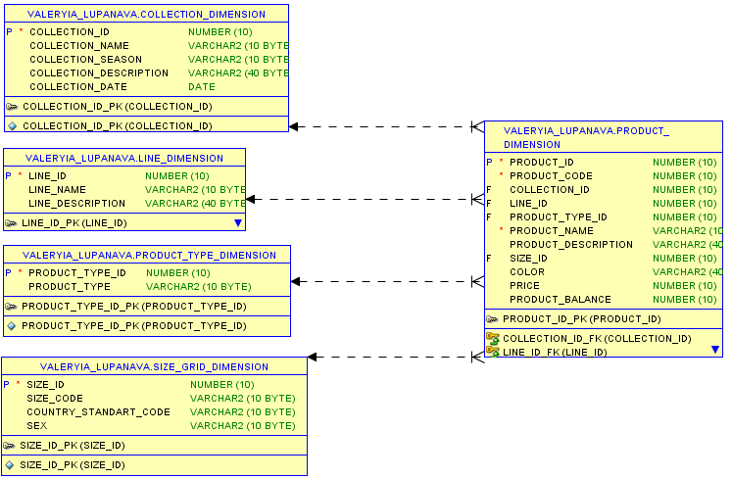

### Store part dimensions

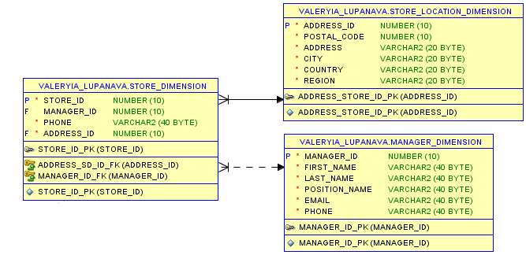

### Customer part dimensions

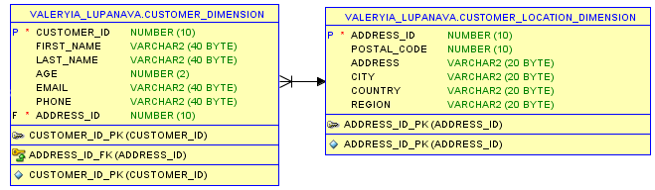

### Promotion dimensions

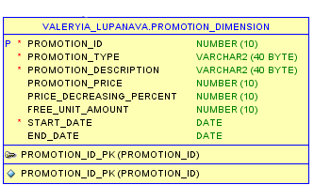

### Sales employee dimension

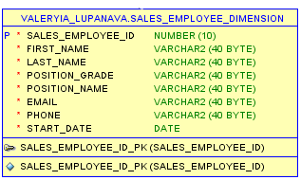

### Payment method dimension

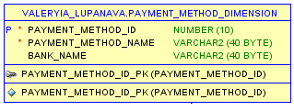

### Date dimension

